**Test Case Examples.**

Admin

1. Creation of 4 new users: Client Owner, Senior Consultant, Consultant and LDS

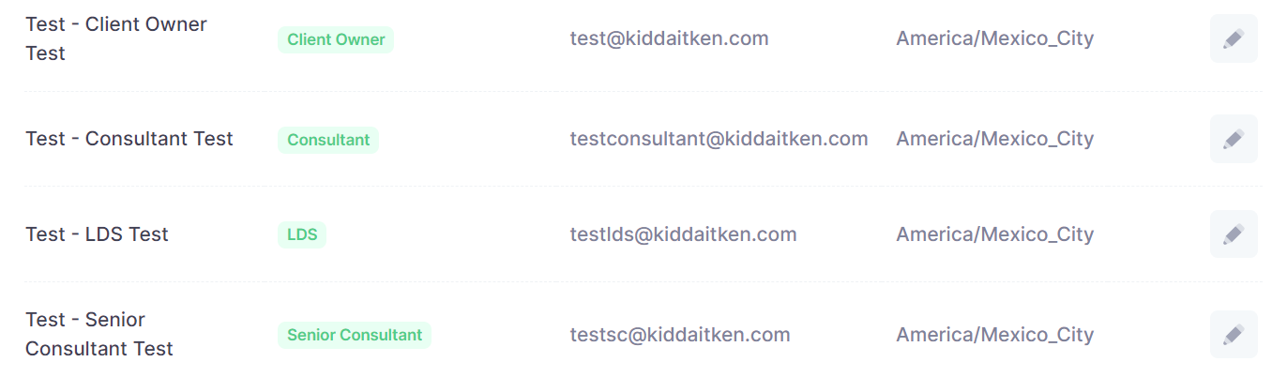

*RA – Added – Creation of a team

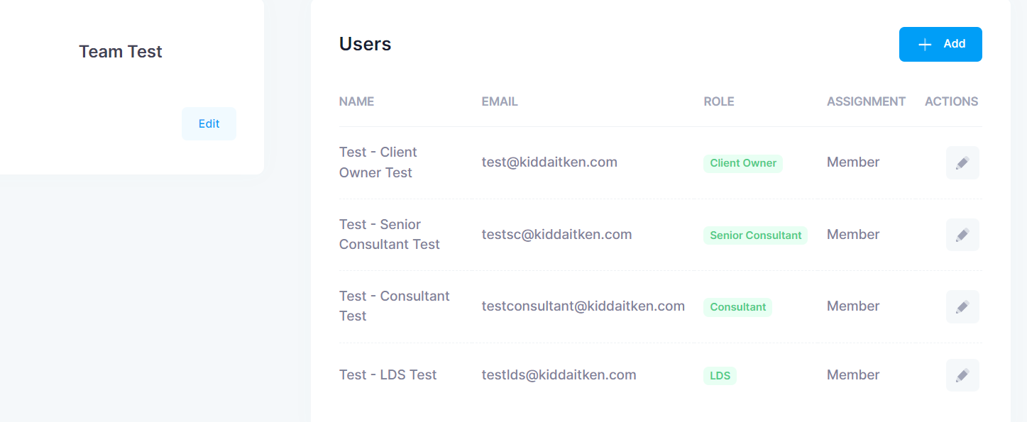

1. Creation of new directory taxonomy (New directory, 2 new guides, 2 locations 10 practices total)

Added *Test – New Directory* with 12 sections and an extra 2 possible “errors” (not very important ones) which I point out later in this section.

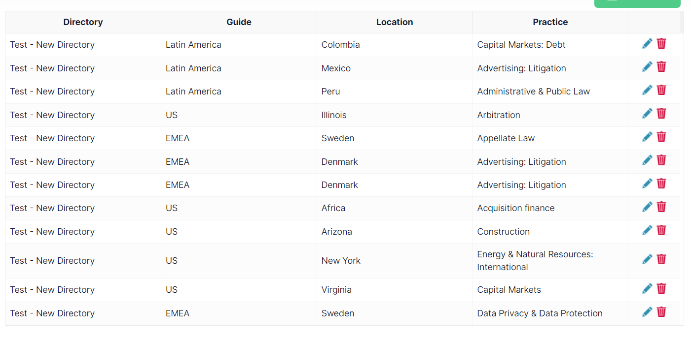

It was not clear that these were clickable, but I guess it’s experienced users who will be creating anything new not everyday users.

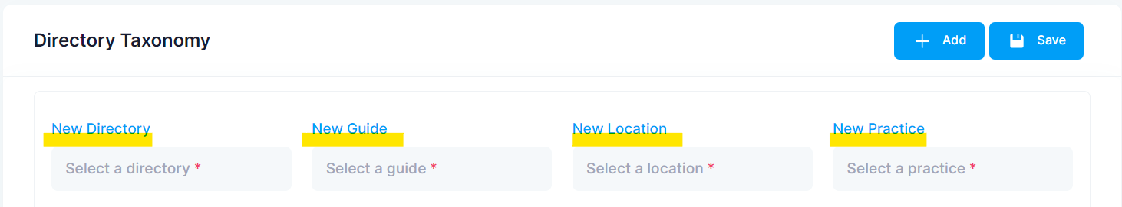

Easy to add Central Practice 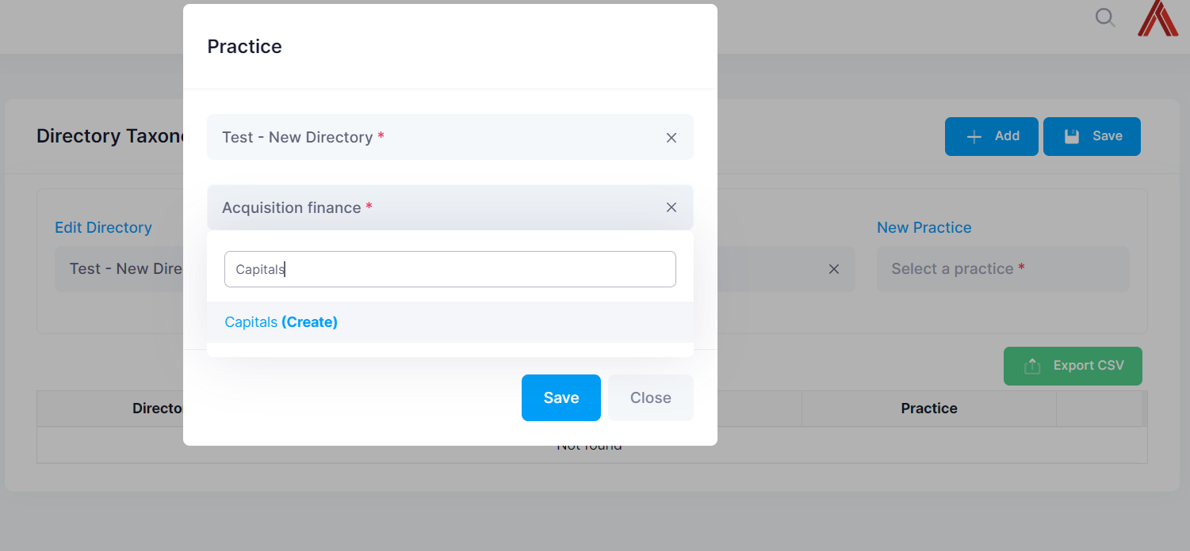

Easy to delete a guide

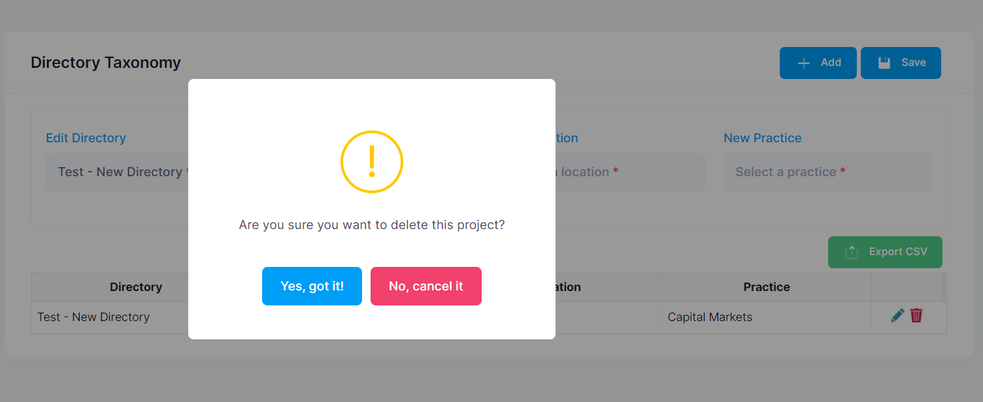

Deleted Asia Pacific Guide and it still shows in option for “select a guide”.

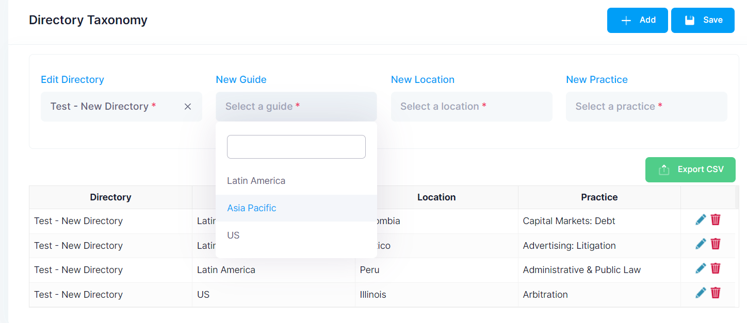

App did not recognize that I added a duplicate – maybe a warning should come up.

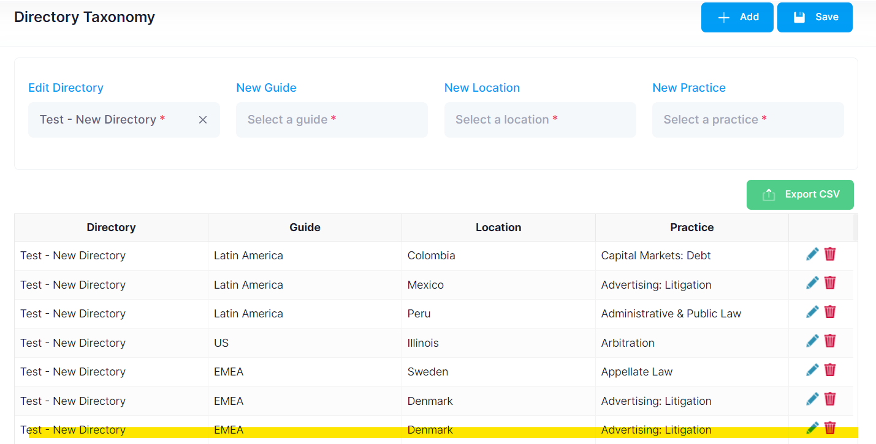

Did not alert me that Guide and Location are not matching – not that important but just testing scenarios

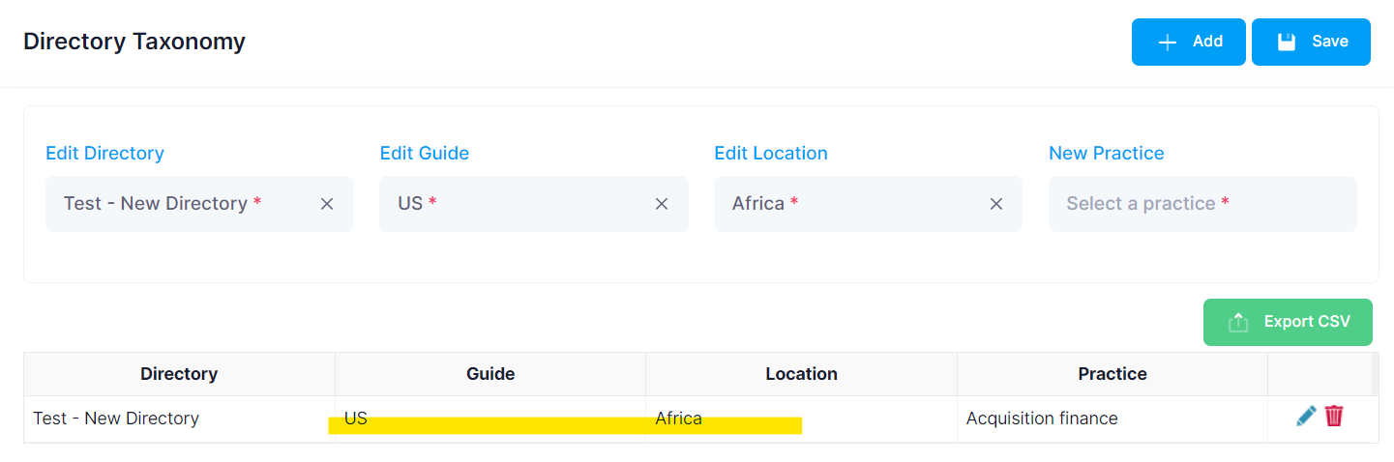

A lot of options for one section – 4 just for Data Privacy and Protection alone and it’s not actually different sections just based on upper/lower case and the type of “and” sign. Not really an issue but just thinking from an excel perspective (which I guess will be similar here), it adds complexity for when you’re searching for something and have to add so many options to the filters which can mean something can get left out. Possibly an issue with being able to **create** a section so easily.

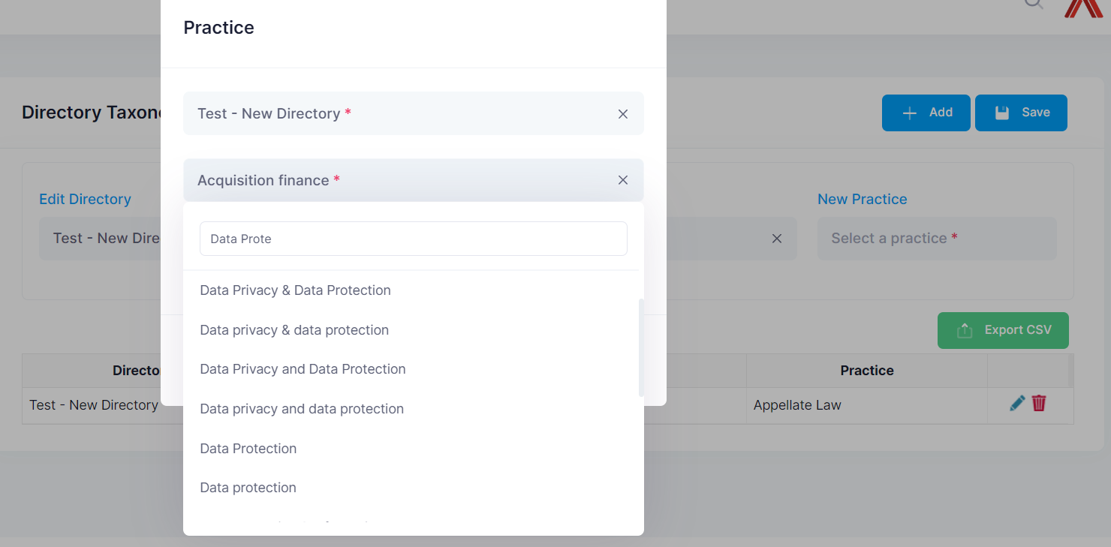

1. Creation of deadline package for the new directory for 2024. Leave 2 without a deadline to test later (overriding). Try to put one practice per month. (I created 10 usable entries from number 2 and I think it may get confusing if I go back to add more now)

Test – New Directory didn’t automatically appear which I initially thought should sync somehow rather than me having to add it but I figured after that we needed to add the year so we can make it easier to add an entire directory for future years as well.

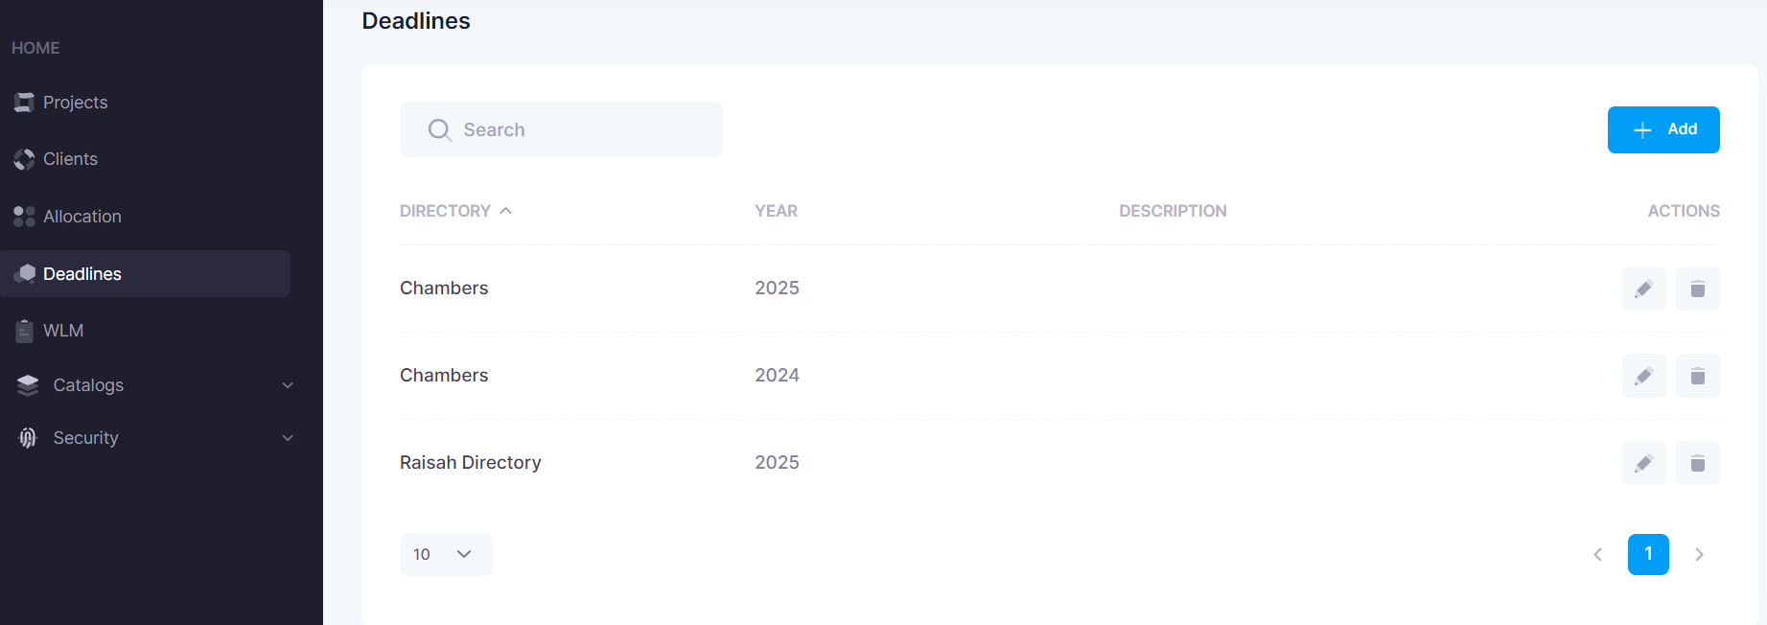

When I added it, it came straight to this page. As you know, if you click on the directory (without using the edit button), it takes you to this screen as well which does not have editing capabilities even though the buttons are there. You can save/overwrite though.

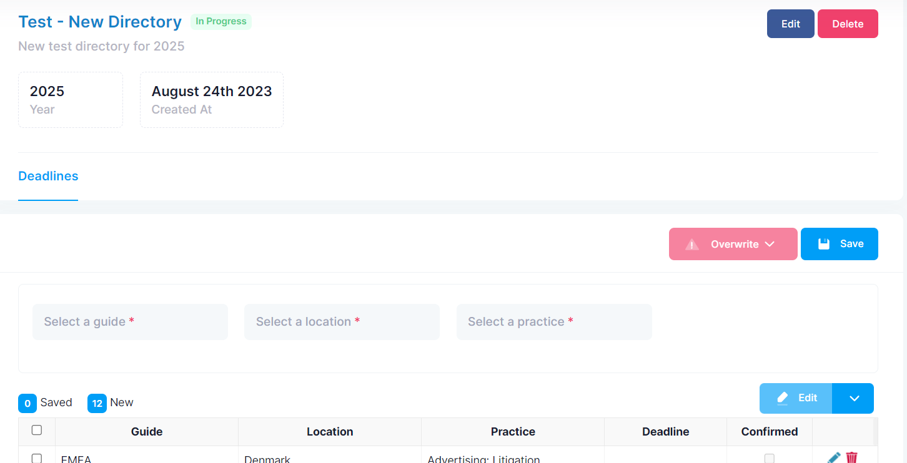

Even on the edit screen, the edit button doesn’t work

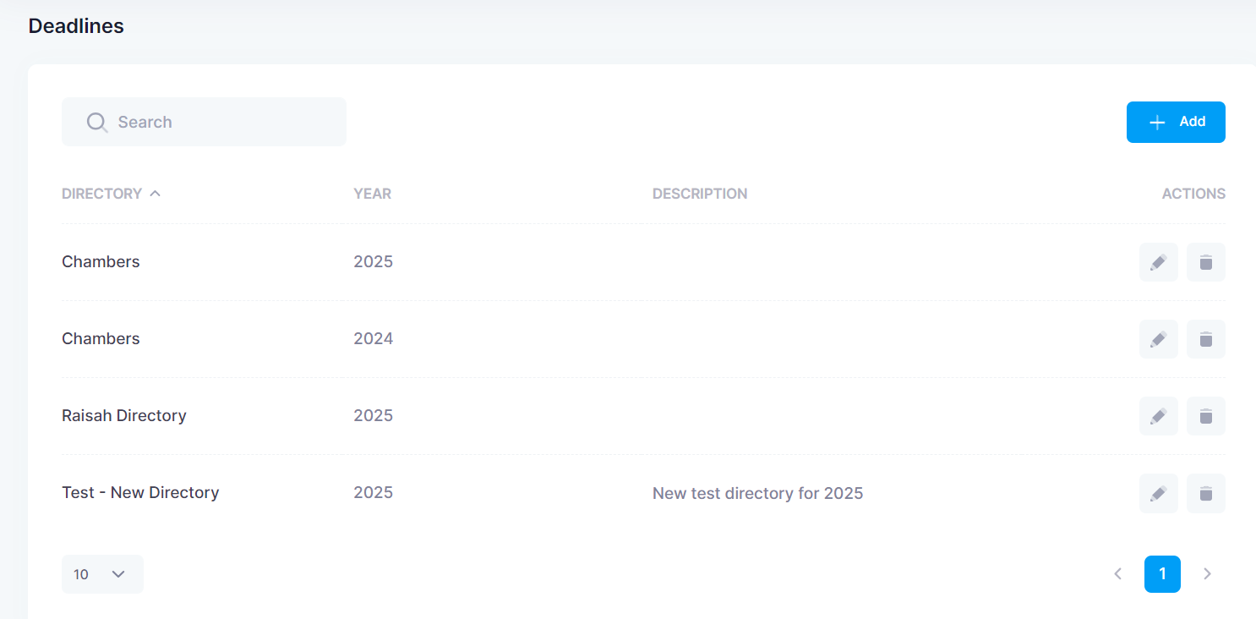

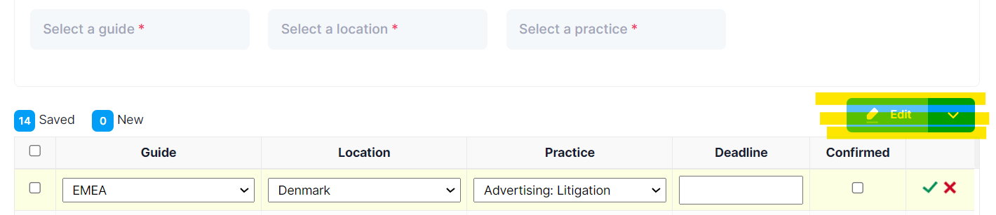

I created 12 sections in the taxonomy screen however on the deadline page there is 13. It added another Denmark – Advertising Litigation (I didn’t realise the number of entries above was cut out in this screenshot)

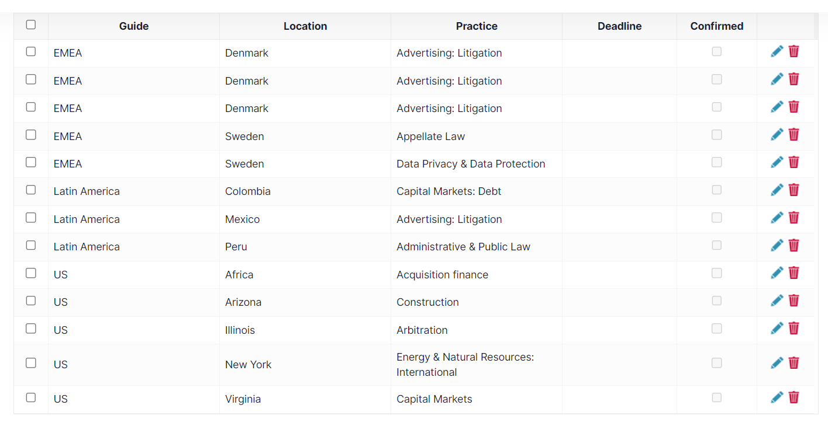

I then added in a deadline for one of them, but did not confirm it to test it but the extra entry disappeared

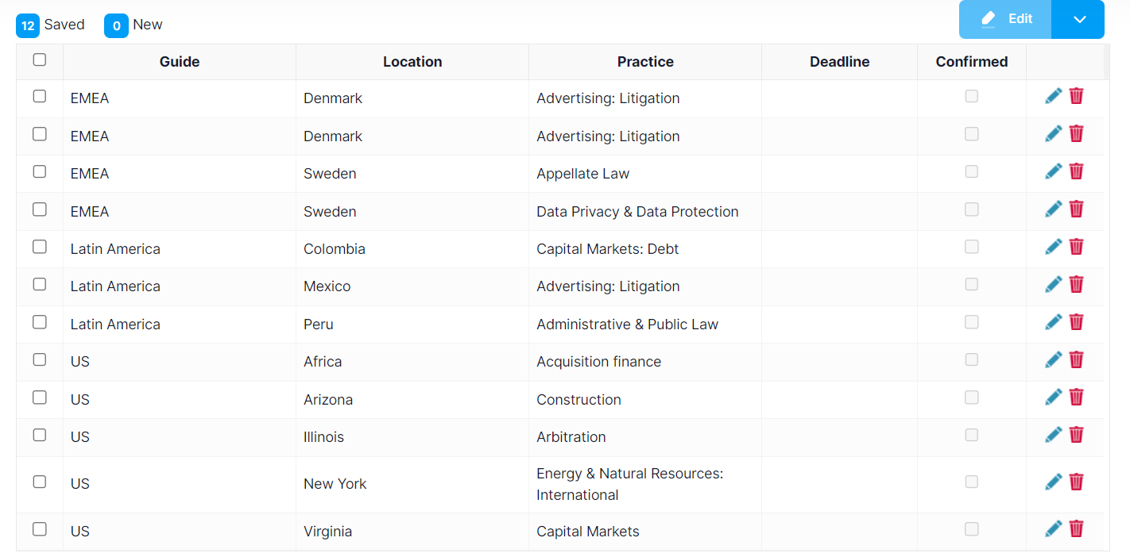

Triple verification required to confirm a deadline – must tick 1) confirm 2) then tick 3) THEN click save. I thought the double verification was not needed so worse yet that it’s 3 clicks *just* to save a deadline. If it was something like deleting a section and asking several times if you’re sure you want to delete it then maybe that level is required but definitely too much for something like a deadline and Jerry mentioned that this page is only handled by admin anyway so no need to worry about too many users accidentally editing it.

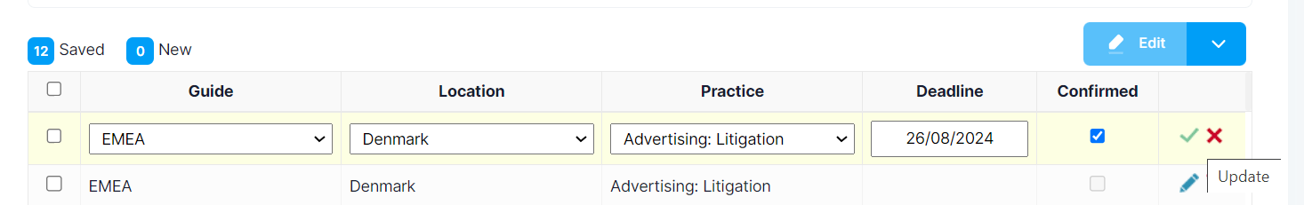

Did not save after double verification – clicked confirm and the tick but did not press save

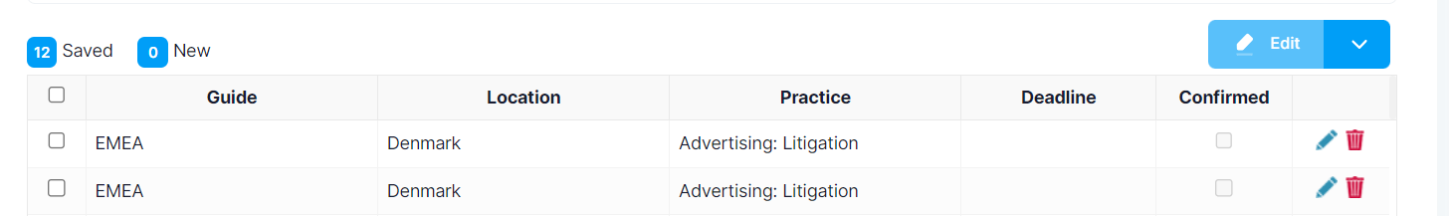

I edited one of the duplicate’s deadline and it changed the other so the system is checking duplicates which is good

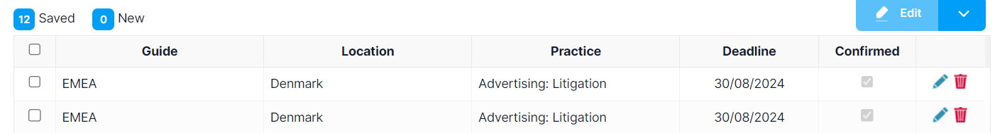

Can set multiple dates before having to click save

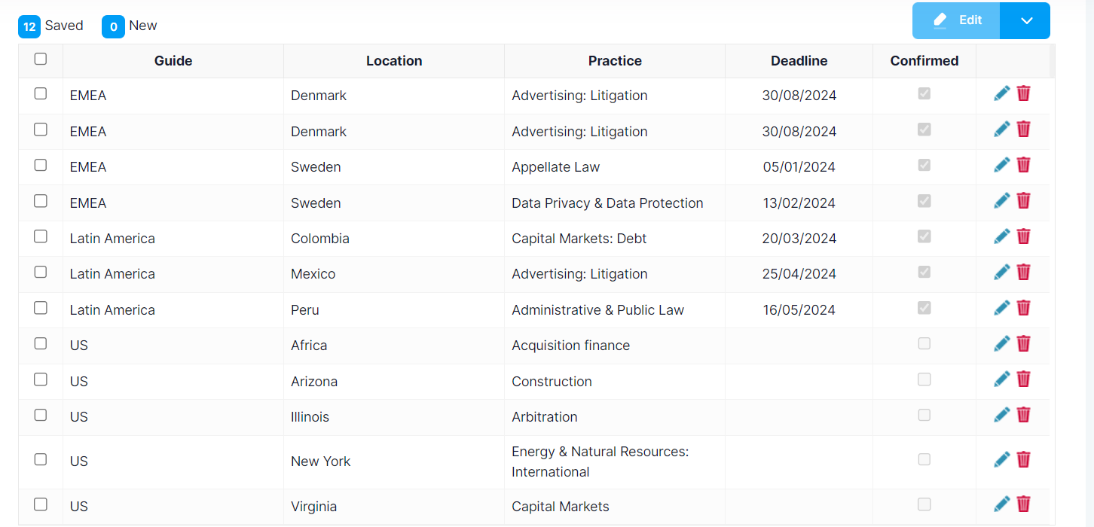

Deleted a deadline for one section (Africa) but then the section disappeared (2nd screenshot)

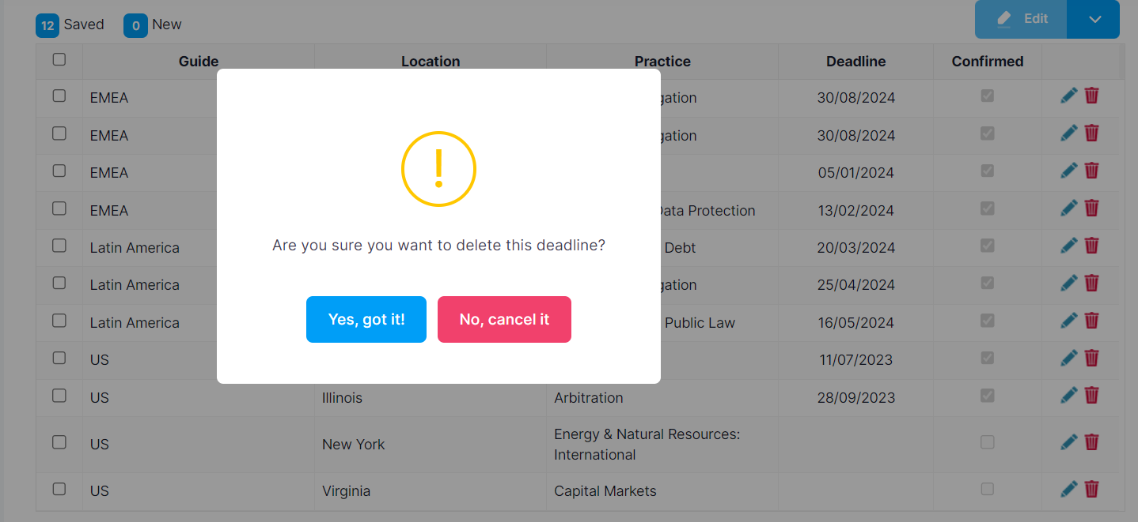

The Africa entry has disappeared and there are only 11 submissions, but the count still says 12.

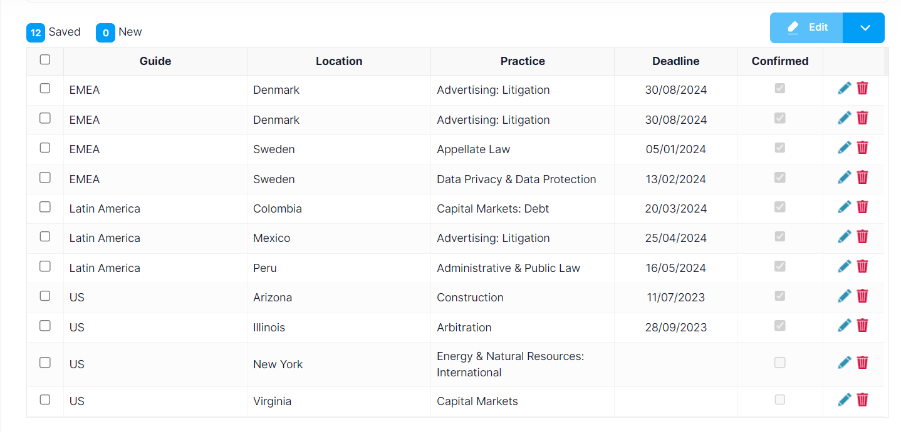

Once I pressed save it re-appeared and changed to 11 Saved, 1 New.

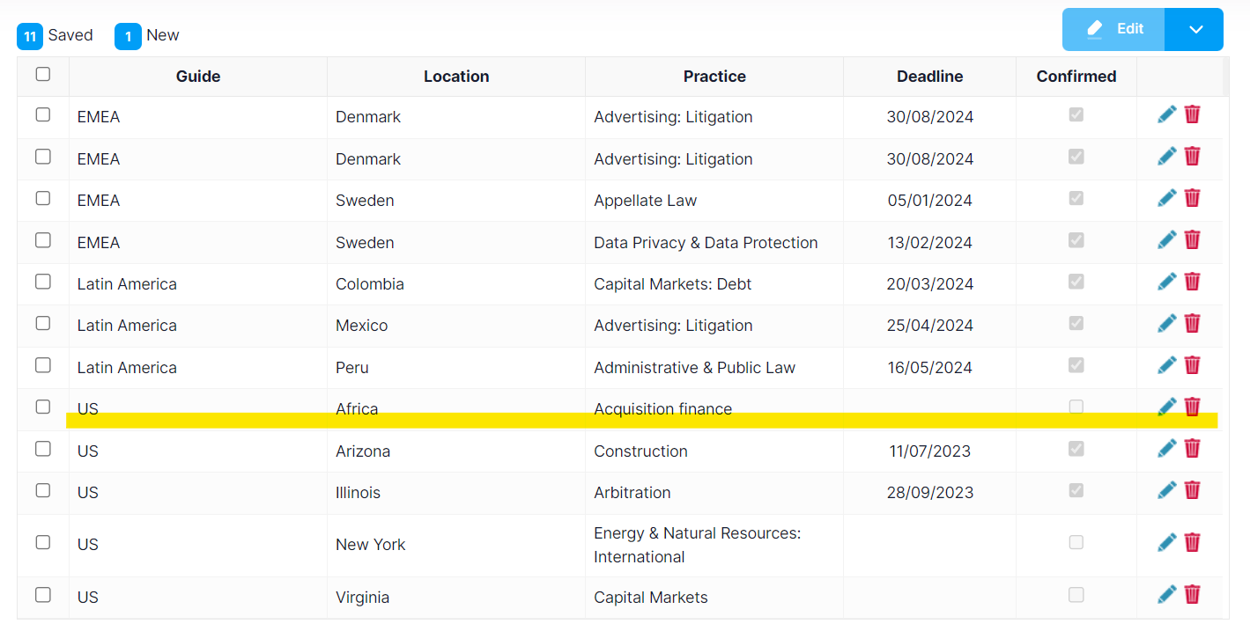

Two deadlines left blank for later overwrite testing

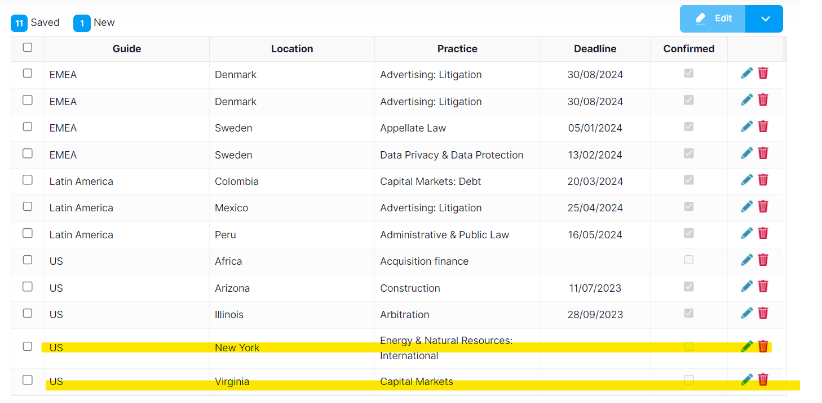

Client Owner

1. Creation of new Client as client owner

STARTED IMPERSONATION - *Test – Client Owner*

Have to scroll through client owner list which is a bit cumbersome

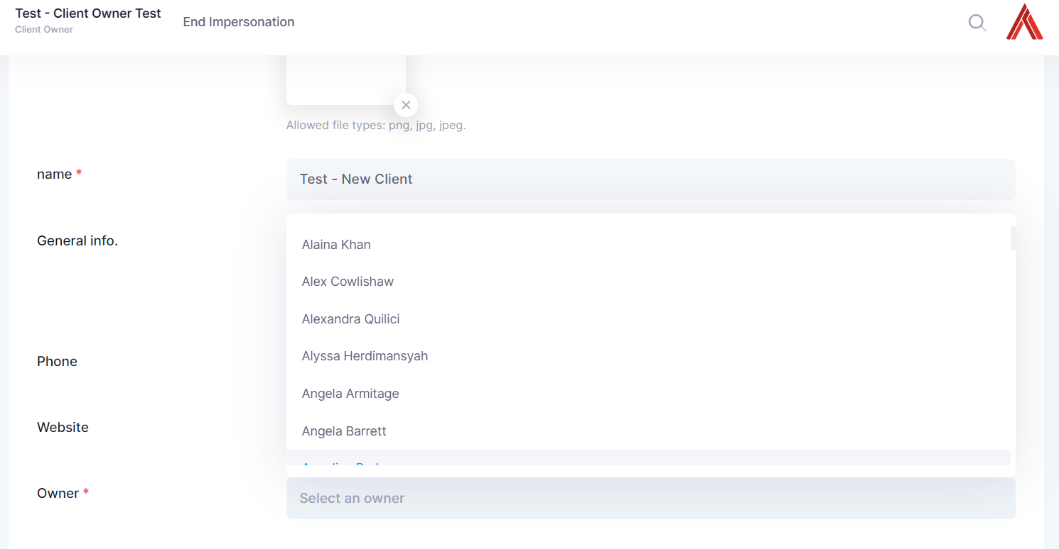

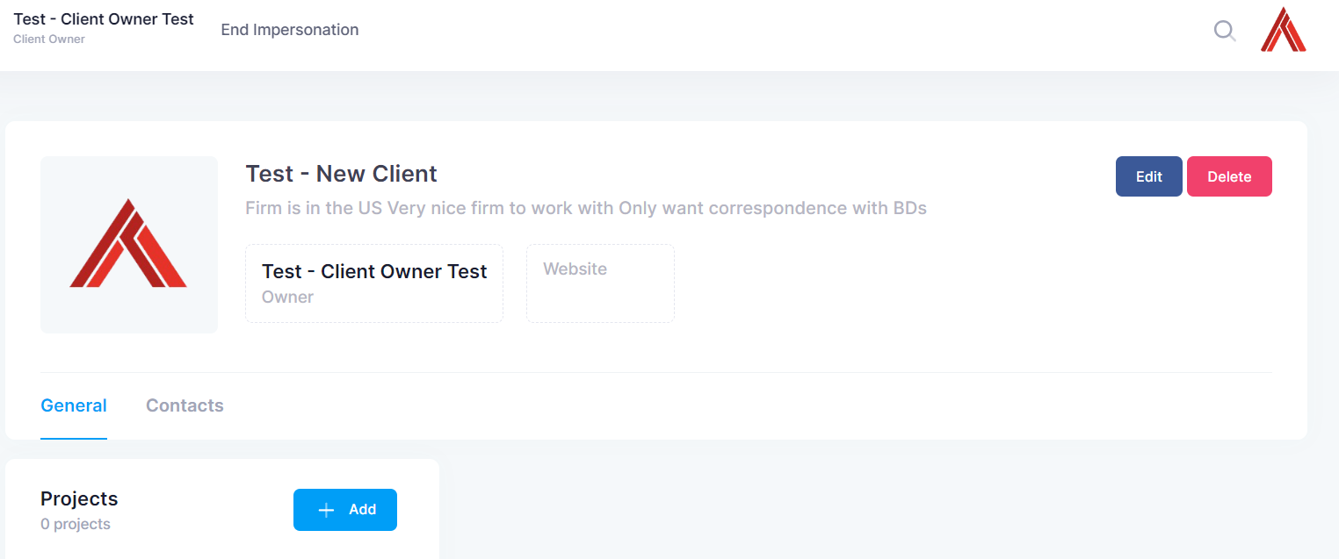

1. Creation of new Project (add practices from the new directory created and validate deadlines are appearing correctly). Add practices without deadlines and validate

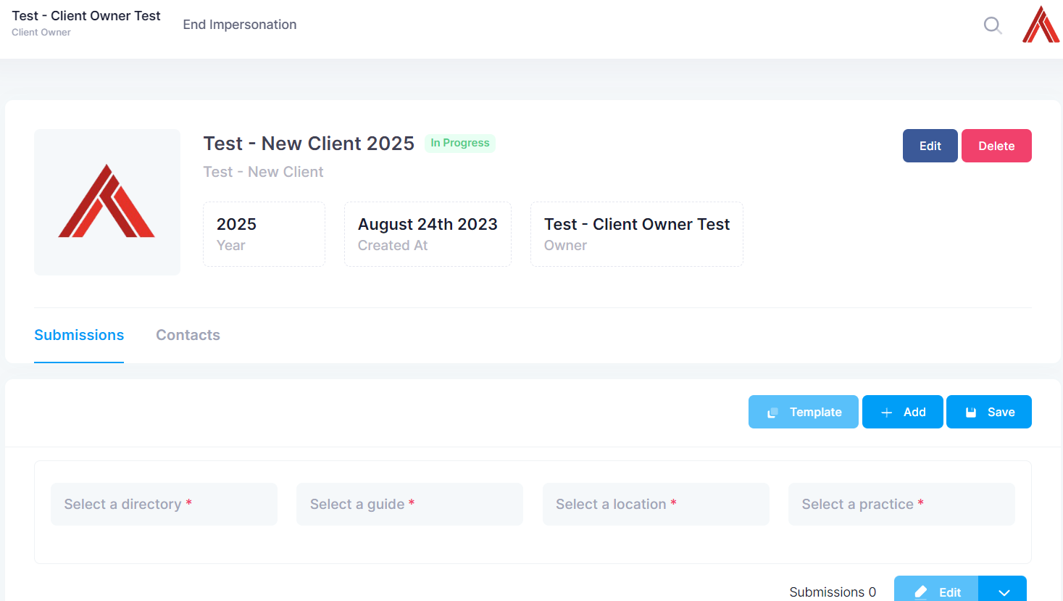

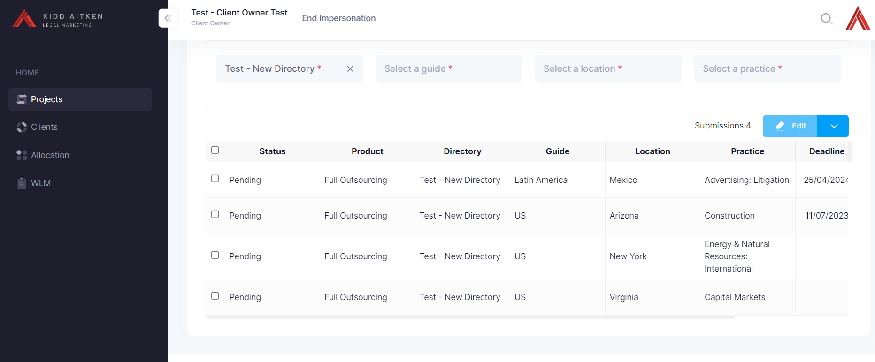

1. Update Deadline package and add missing deadlines, do an override. Validate deadlines now appear on project correctly.

ENDED IMPERSONATION - *Test – Client Owner*

Pressed overwrite > all >“yes” and said it was successfully saved so I went back to check if it was saved and it didn’t show in projects.

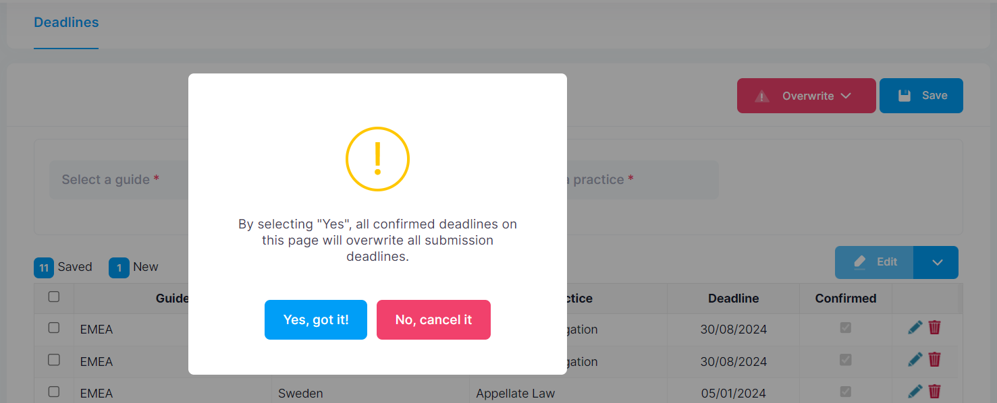

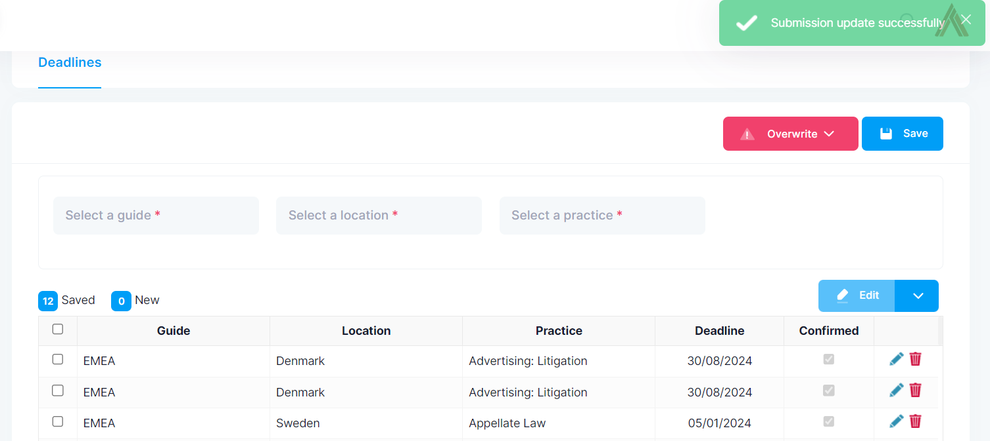

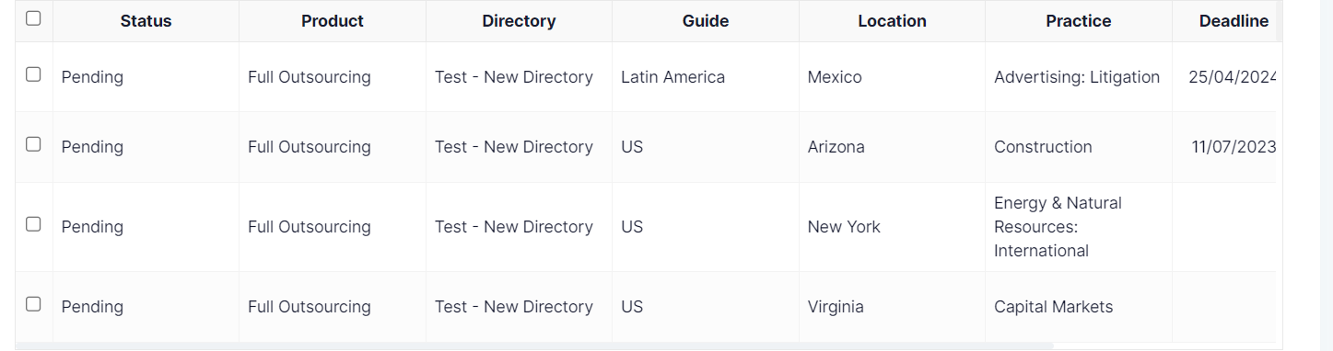

Even after pressing save, it looks like the overwrite didn’t work. Also tried changing the date and just pressing save, obviously didn’t work either (as it should be since I didn’t say overwrite).

Pressed overwrite > today >“yes” and it worked this time, the view is slightly off as it cuts off the end of the 2024 and the edit button does not work.

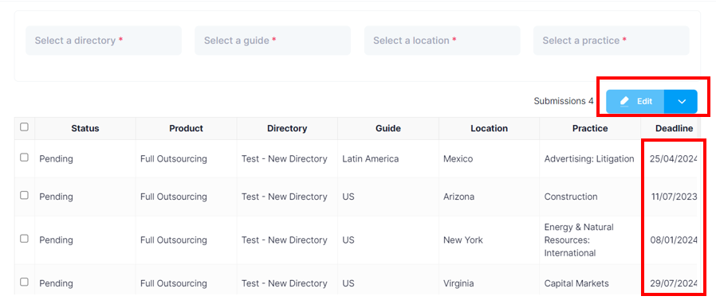

Would be nice to be able to add multiple sections at a time. I believe Jerry mentioned that’s what the template would be for later.

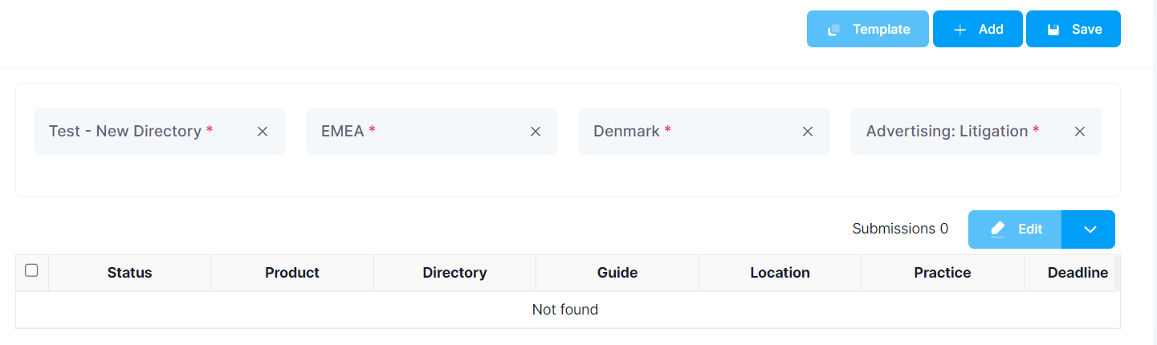

Added 10 sections to the project

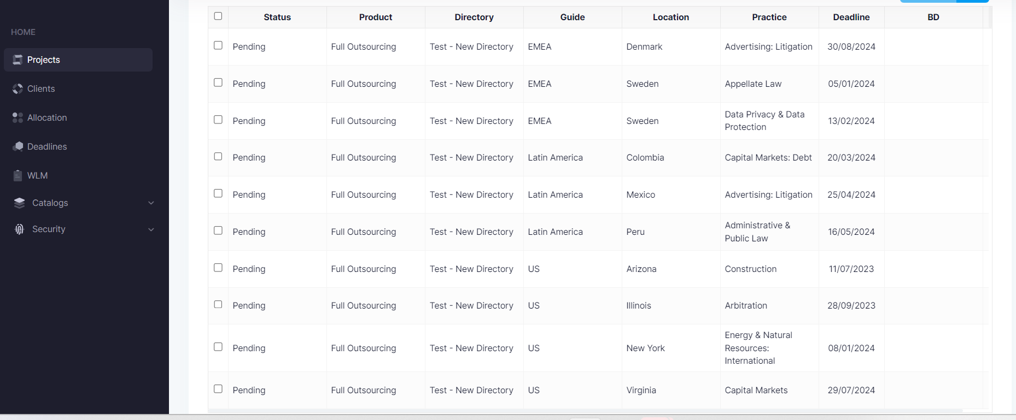

1. Do allocation. Allocate work for the client owner team: SC, Consultant and LDS.

STARTED IMPERSONATION – *Test – Client Owner*

First impression, it looks like deadline is cut off, only when I scrolled down the page, I realised I could scroll across and see more information.

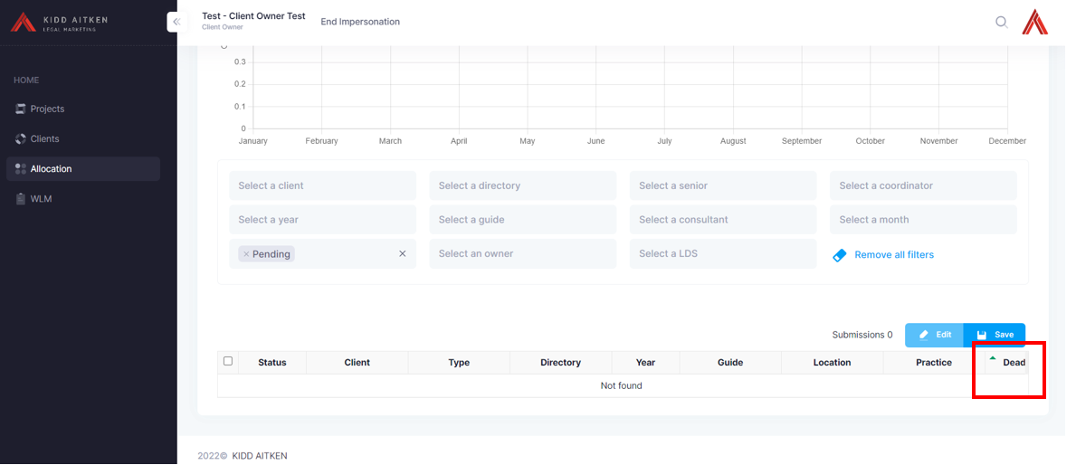

Test – New Client does not show up.

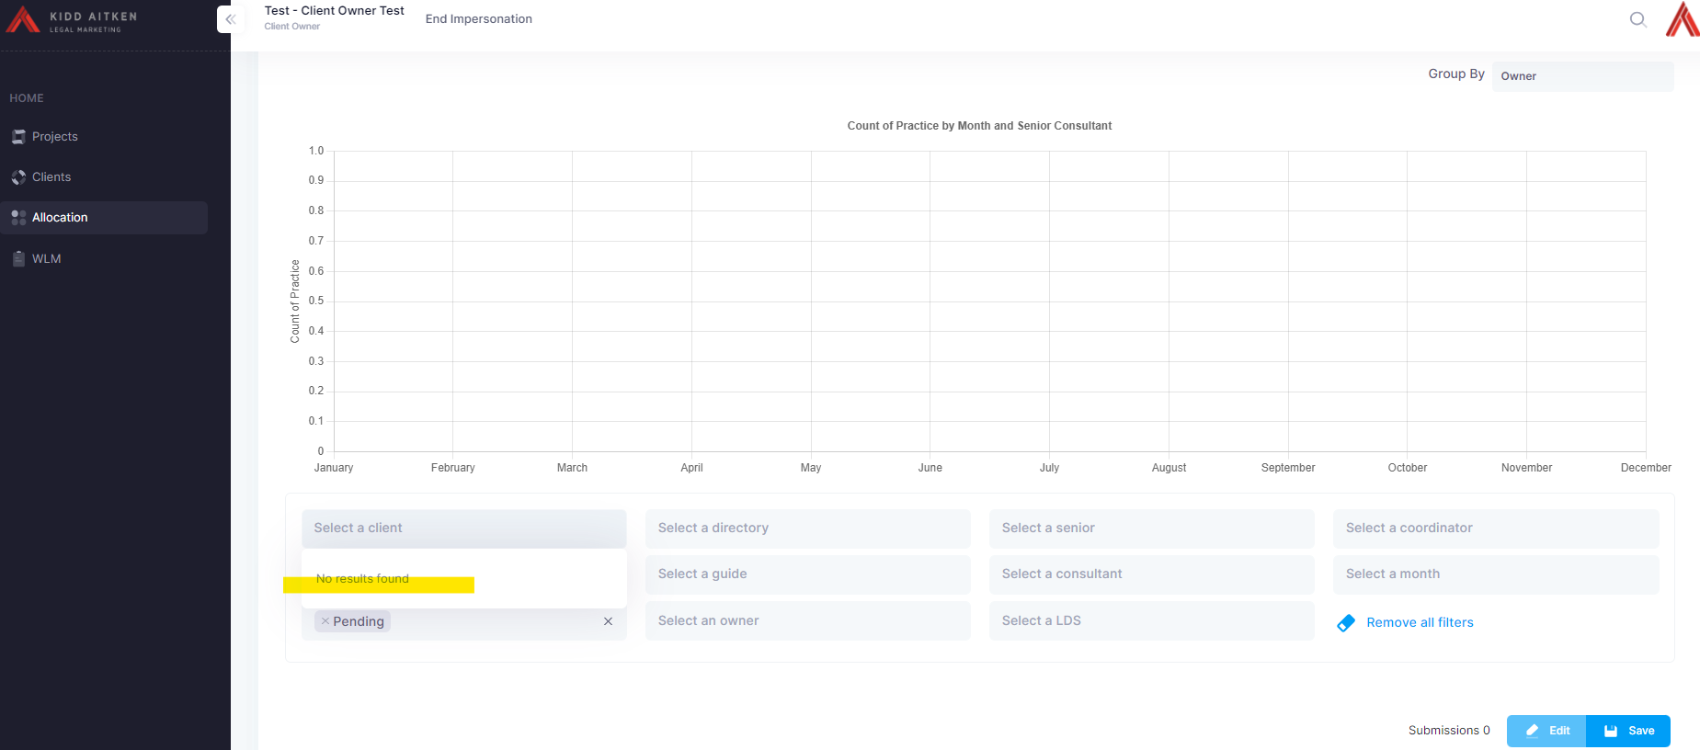

When I pressed “select a senior”, I was able to select the blank option and all the sections came up

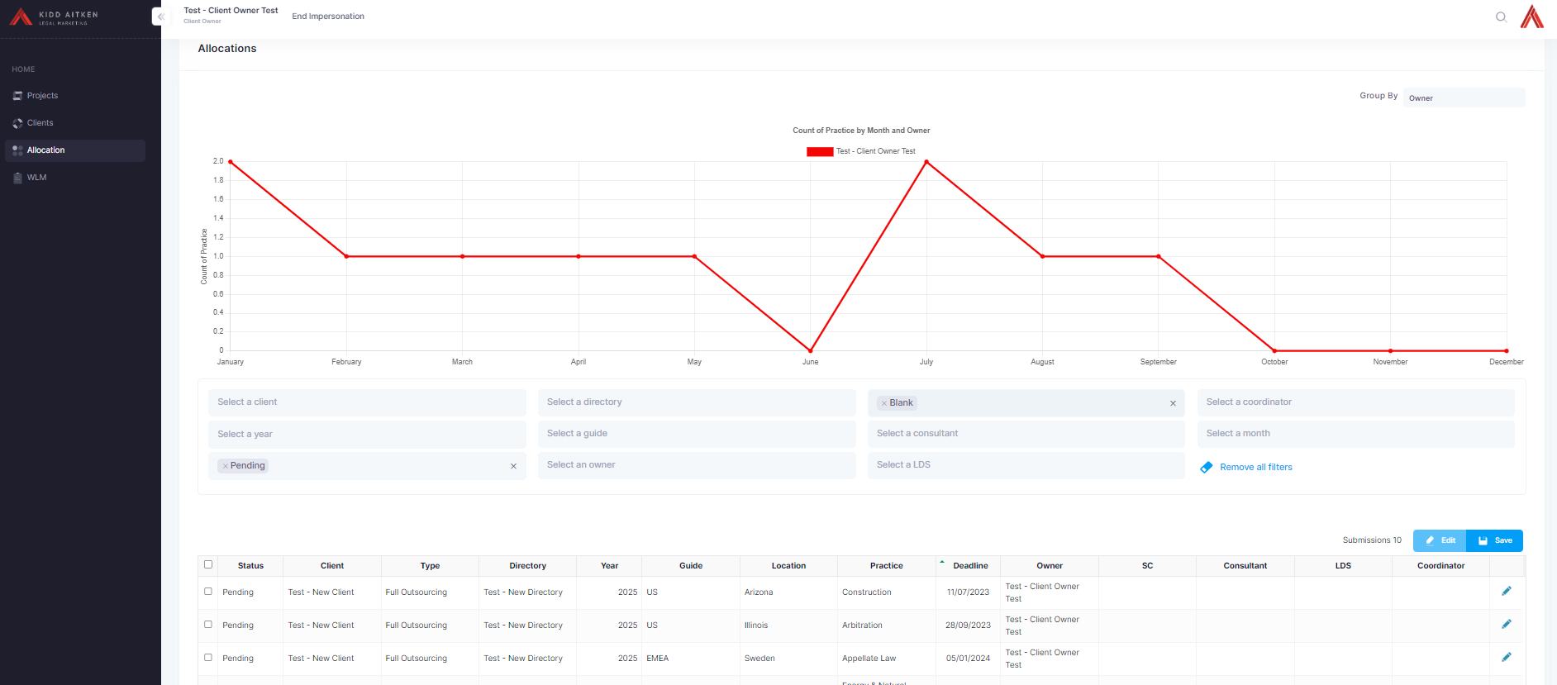

However, I was still not able to allocate to anyone – SC, Consultant, LDS were all blank. And I was not able to edit Coordinator.

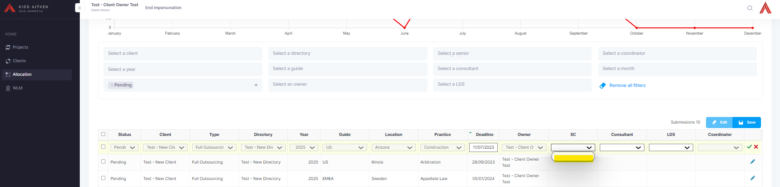

END IMPERSONATION – *Test – Client Owner*

From Admin profile:

1. I checked that *Team Test* was created which it was, however, the *Test - Client Owner* was not able to allocate to anyone on this team.

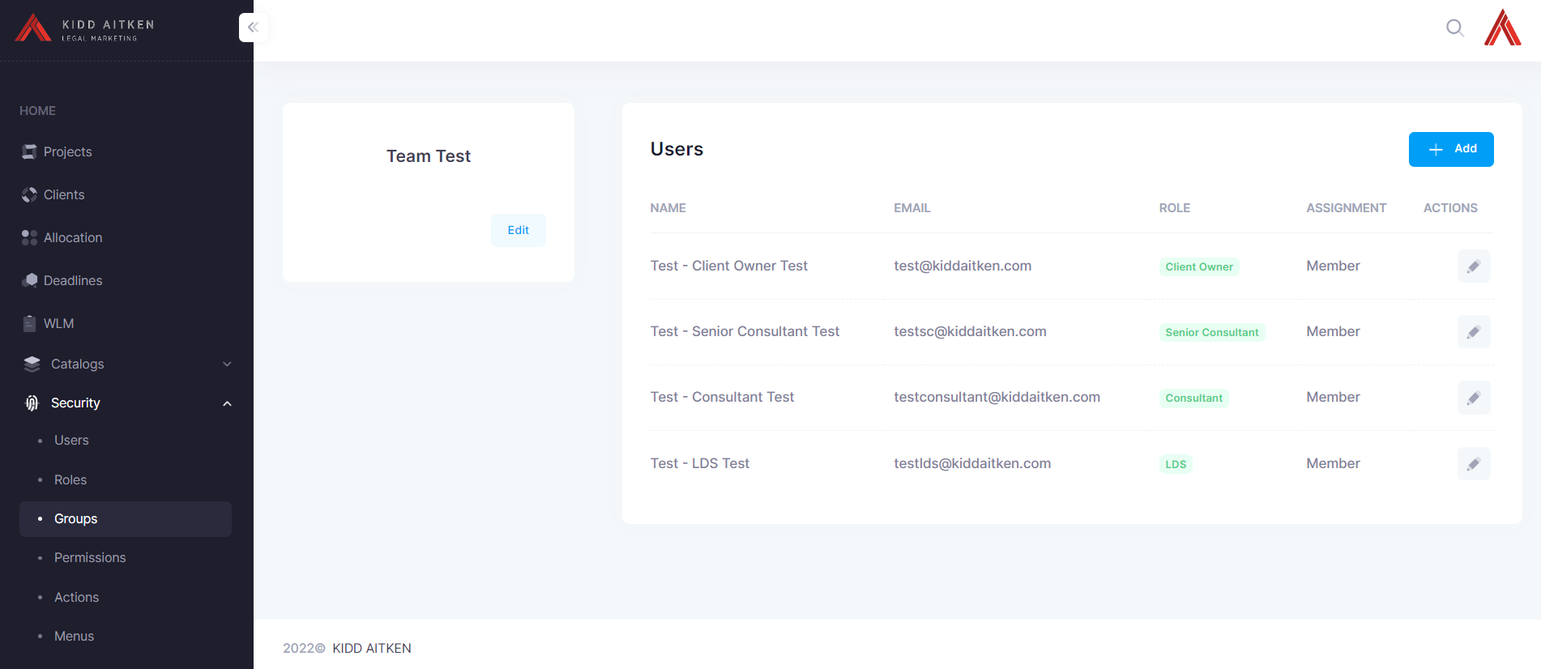

1. Also checked that the *Test – New Client* existed, which it does.

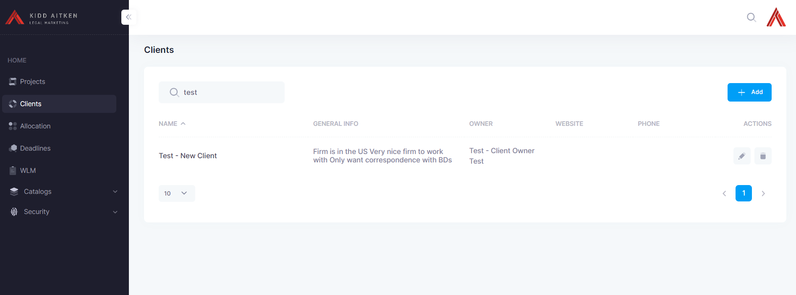

1. Checked for *Test – New Client* on allocation page and it does not exist.

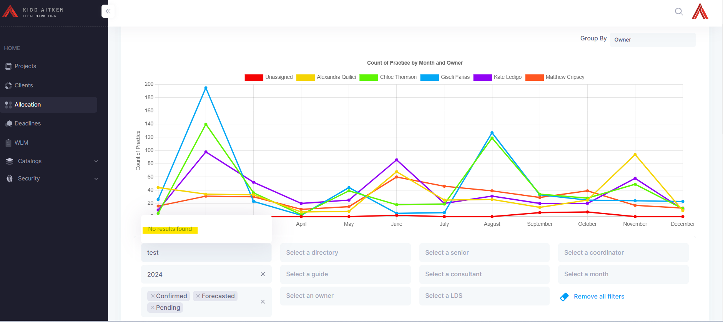

BASED ON THESE FINDINGS, I WAS NOT ABLE TO DO FURTHER TESTING.

1. Validate WLM: Work is displayed properly. Update sub status.

Senior consultant

1. Validate Allocation and try reallocation work to his team. This might be difficult since it will only appear his team and might not be able to assign anyone else. Document scenario.
2. Open up WLM and try updating it.

Consultant and LDS

1. Open WLM and try making updates with both